NXT STUDIO
IoT Data Analyst Internship
Week 1 Report

Submitted By
Name: Saniya Syed
Course: B.Tech – CSE (INTERNET OF THINGS)
College: Jain (Deemed-to-be University)

Submitted To
NXT Studio

Internship Duration
12 Weeks

Report
Week 1 – Introduction to IoT and Development Environment

Date
11 July 2026

Table of Contents:-
1. Introduction
2. Objectives of Week 1
3. What is IoT?
4. IoT Architecture
5. Components of IoT
6. Sensors and Actuators
7. IoT Communication Protocols
8. MQTT vs HTTP Comparison
9. Edge Computing
10. Applications of IoT
11. Development Environment Setup
12. Tools Used
13. Learning Outcomes
14. Conclusion

1. Introduction
The Internet of Things (IoT) is one of the fastest-growing technologies in the modern digital world. It connects physical devices such as sensors, machines, home appliances, vehicles, and industrial equipment to the internet, allowing them to collect, exchange, and analyze data without requiring continuous human intervention.
The purpose of Week 1 was to understand the fundamentals of IoT and prepare the software environment required for the internship. During this week, I studied IoT architecture, sensors, actuators, communication protocols, edge computing, and installed essential development tools including Python, VS Code, Git, GitHub, and Jupyter Notebook.

2. Objectives of Week 1
The primary objectives of this week's internship were:
- Understand the basic concepts of IoT.
- Learn the working principle of IoT architecture.
- Study different types of sensors and actuators.
- Learn IoT communication protocols such as MQTT and HTTP.
- Understand Edge Computing.
- Install and configure Python, VS Code, Git, GitHub, and Jupyter Notebook.
- Create a GitHub repository for internship submissions.

3. What is IoT?
The Internet of Things (IoT) is a network of interconnected physical devices that communicate over the internet to collect, share, and process data. These devices contain sensors, processors, communication modules, and software that allow them to perform intelligent tasks automatically.
IoT improves automation, reduces manual work, increases efficiency, and enables real-time monitoring across multiple industries.
Example
A smart home temperature sensor continuously measures room temperature. When the temperature exceeds a predefined limit, it automatically switches on the air conditioner without requiring human intervention.

4. IoT Architecture
The IoT architecture consists of several layers that work together to collect, transmit, process, and visualize data.
Sensing Layer
Collects real-world data using sensors such as temperature, humidity, motion, and light sensors.
Network Layer
Transfers sensor data to the cloud or server using communication technologies like Wi-Fi, Bluetooth, MQTT, or HTTP.
Data Processing Layer
Processes, stores, and analyzes the received data to generate useful information.
Application Layer
Displays the processed data to users through mobile apps, web dashboards, or other IoT applications.
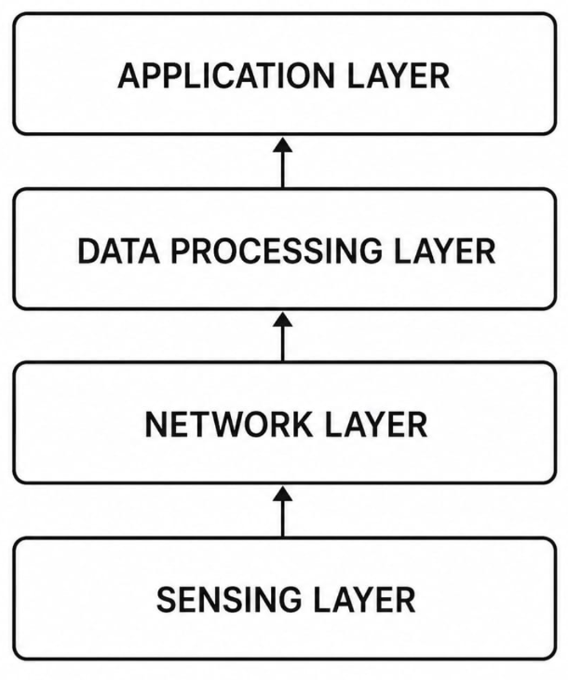
IoT Architecture
_____________________________________________________________
5. Components of IoT
Sensors
Sensors are input devices that collect information from the surrounding environment.
Examples include:
- Temperature Sensor
- Humidity Sensor
- Motion Sensor
- Gas Sensor
- Ultrasonic Sensor
- Light Sensor
- Pressure Sensor
Functions
- Detect environmental conditions
- Convert physical quantities into electrical signals
- Send data for processing

Actuators
Actuators are output devices that perform physical actions according to commands received from the system.
Examples include:
- LED
- Motor
- Fan
- Relay
- Buzzer
- Servo Motor
Functions:
- Switch devices ON/OFF
- Rotate motors
- Control industrial equipment
- Generate alerts

Connectivity
IoT devices communicate using various networking technologies.
Common technologies include:
- Wi-Fi
- Bluetooth
- Zigbee
- LoRaWAN
- Cellular (4G/5G)
- Ethernet
Connectivity ensures secure and reliable communication between devices and cloud platforms.

Cloud Computing
Cloud platforms store and process IoT data.
Popular cloud platforms include:
- AWS IoT Core
- Microsoft Azure IoT Hub
- Google Cloud IoT
- IBM Watson IoT
Cloud computing enables remote monitoring, data backup, scalability, and centralized management.

Data Analytics
Data analytics converts raw sensor readings into meaningful insights.
It helps to:
- Detect anomalies
- Predict failures
- Generate reports
- Support business decisions
- Improve operational efficiency

6. Sensors vs Actuators
Sensors | Actuators
Input devices | Output devices
Collect data | Perform actions
Detect environmental changes | Execute commands
Example: Temperature Sensor | Example: Motor

7. IoT Communication Protocols
Communication protocols enable IoT devices to exchange information efficiently.
MQTT
MQTT (Message Queuing Telemetry Transport) is a lightweight messaging protocol designed specifically for IoT applications.
Features
- Publish–Subscribe architecture
- Lightweight
- Low bandwidth consumption
- Fast communication
- Reliable message delivery
Advantages
- Efficient for low-power devices
- Suitable for unstable networks
- Scalable

HTTP
HTTP (HyperText Transfer Protocol) is the standard communication protocol used on the web.
Features
- Client–Server architecture
- Request–Response model
- Easy implementation
- Widely supported
Advantages
- Easy integration with web applications
- Secure communication using HTTPS
- Ideal for REST APIs

8. MQTT vs HTTP
Feature | MQTT | HTTP
Communication Model | Publish–Subscribe | Request–Response
Speed | Fast | Moderate
Bandwidth Usage | Low | Higher
Power Consumption | Low | Higher
Best For | IoT Devices | Web Applications

9. Edge Computing
Edge Computing processes data close to the source rather than sending all information to the cloud.
Advantages
- Lower latency
- Faster decision-making
- Improved security
- Reduced bandwidth usage
- Better real-time performance
Applications
- Autonomous Vehicles
- Smart Manufacturing
- Smart Traffic Systems
- Healthcare Monitoring
- Smart Agriculture
- Industrial Automation

10. Applications of IoT
IoT is used in numerous industries, including:
Smart Homes
Control lighting, fans, locks, and security cameras remotely.
Healthcare
Monitor patient health using wearable devices and smart medical equipment.
Agriculture
Monitor soil moisture, weather conditions, and irrigation systems.
Smart Cities
Manage traffic signals, parking systems, waste management, and street lighting.
Industrial IoT
Monitor machinery, predict equipment failures, and improve production efficiency.

11. Development Environment Setup
During Week 1, the following software tools were successfully installed and configured.
Tool | Purpose
Python | Programming Language
VS Code | Code Editor
Git | Version Control
GitHub | Project Repository
Jupyter Notebook | Interactive Python Development
The environment was tested successfully by running Python programs and Jupyter notebooks
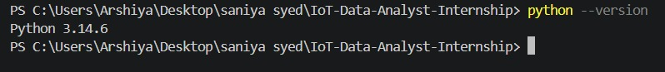
Python Installation Verification

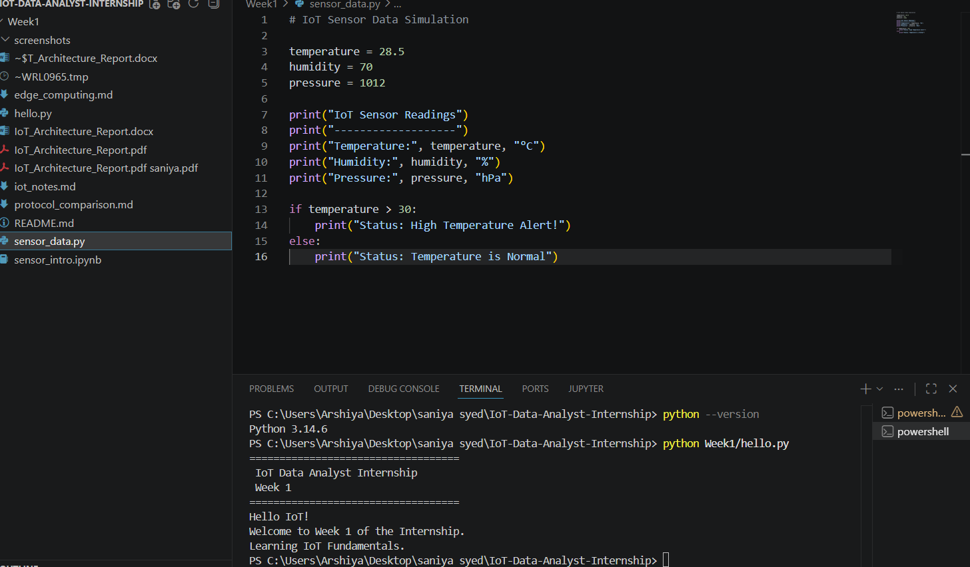
VS Code Workspace

12. Practical Work Completed
During Week 1, the following files were created:
- README.md
- hello.py
- sensor_data.py
- sensor_intro.ipynb
- iot_notes.md
- protocol_comparison.md
- edge_computing.md
These files demonstrate understanding of IoT concepts, basic Python programming, and notebook-based analysis.
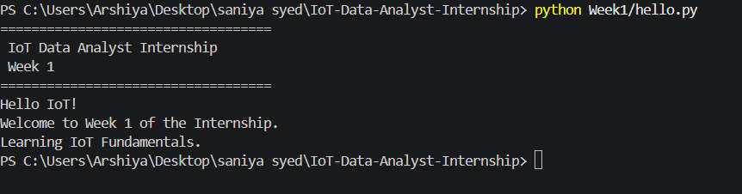
hello.py Program Output

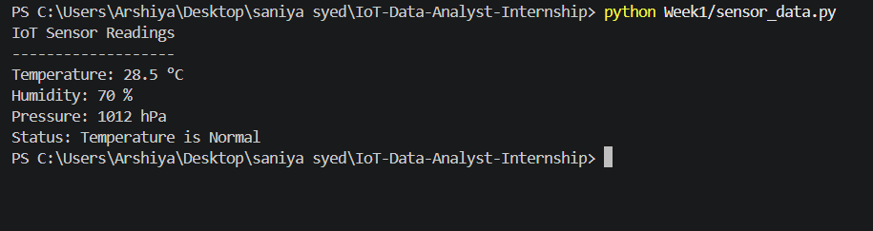
sensor_data.py Program Output
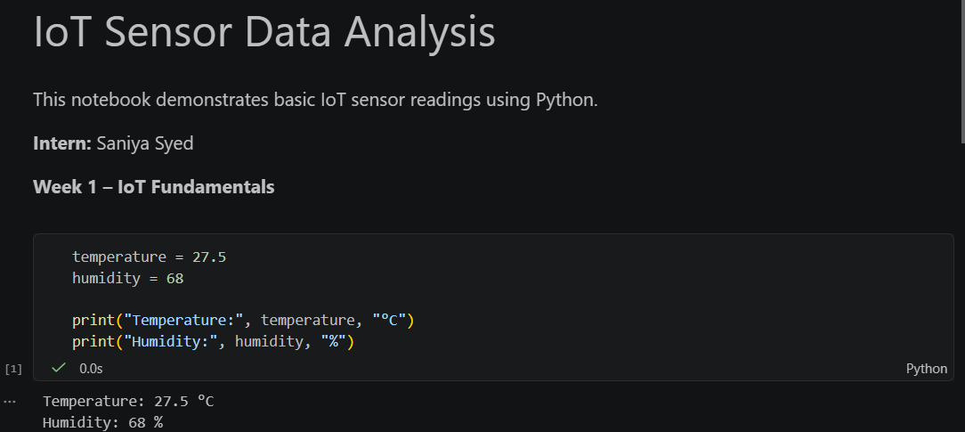
Jupyter Notebook Execution

13. Learning Outcomes
By the end of Week 1, I was able to:
- Understand IoT fundamentals.
- Explain IoT architecture.
- Differentiate between sensors and actuators.
- Compare MQTT and HTTP communication protocols.
- Understand Edge Computing.
- Configure the complete Python development environment.
- Use Git and GitHub for project management.
- Create Python scripts and Jupyter notebooks.

14. Conclusion
Week 1 provided a strong foundation for the IoT Data Analyst Internship. I gained a clear understanding of IoT concepts, architecture, communication protocols, sensors, actuators, and edge computing. I also successfully set up the required development environment by installing Python, VS Code, Git, GitHub, and Jupyter Notebook.
Additionally, I created and executed basic Python programs, documented my learning using Markdown files, and organized the project in a GitHub-ready repository. These activities have prepared me for upcoming weeks, where I will work with IoT sensor data, perform data cleaning and analysis, create visualizations, and develop analytical solutions for real-world IoT applications.

